Academic Year 19-20
AVISHKAR
- Got Second Prize at 14th Maharashtra State Inter University Avishkar Research Convention: 2019-20 for research project titled “Portable Refrigeration System for Vaccine Distribution for Remote Location.” (Certificate + Trophy + 30k cash)
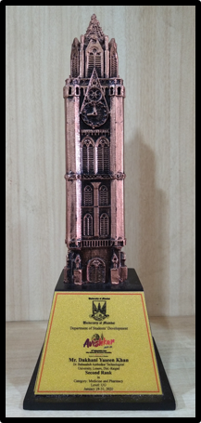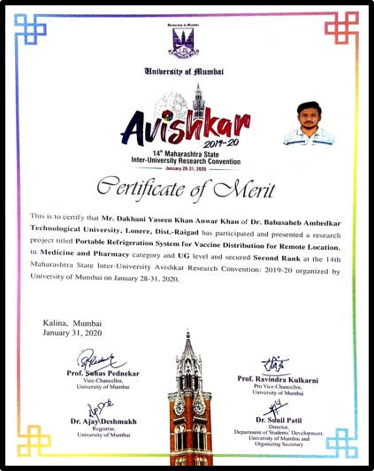
- Got First Prize at University Level Avishkar Project Competition at DBATU, Lonere
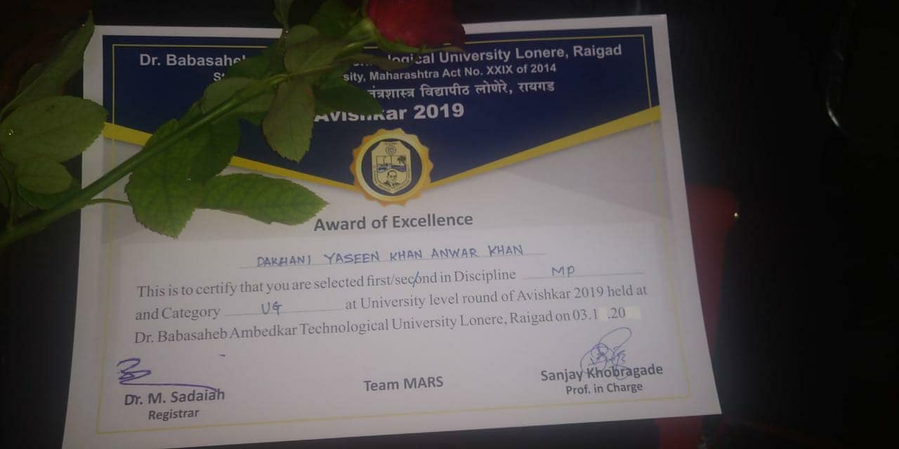
- Got Second Prize at Zonal Level Avishkar Project Competition held by DBATU at Nutan College of Engineering, Pune

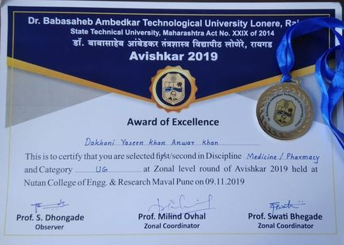
AUTODESK
- Autodesk Design Competition under Solapur region Bagged 1st Prize for the project “Portable Refrigeration System for Vaccines Distribution at Rural and Remote Location”
Gift Voucher of Rs. 10,000/- and Certificate
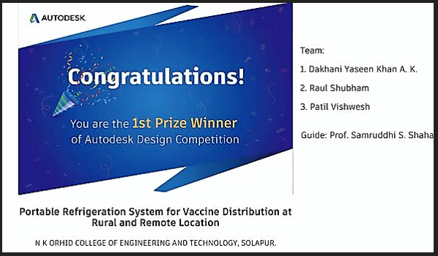

Smart India Hackathon 2019 Participation

Students of the N.K. Orchid College of Engineering and technology, Solapur have been selected for Smart India Hackathon (SIH) 2019 (hardware Edition) grand finale, to be held from July 8 to 12, at the Nodal Centre of NIT Trichy.
Students from the departments of Electrical Engineering participate in the event.
Student have developed the product which will Increase Life Span of LED Driver which displayed in the competition.
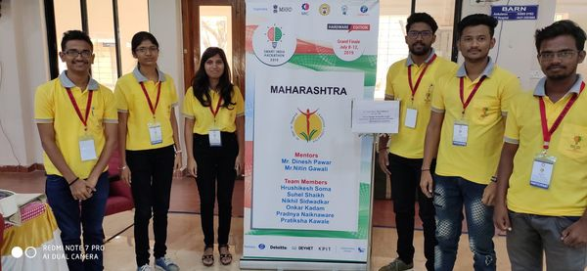

Dassault Systemes (AY 20-21) Participation:
- Selected for top 100 projects through all over India in Project of the year 2020 (POTY 2020) held by La Foundation Dassault Systemes, France in month of July 2020 With the project titled “Portable Refrigeration System for Vaccine Distribution to Remote Location”
Link of the POTY 2020 Website: https://academy.3ds.com/en/node/19143
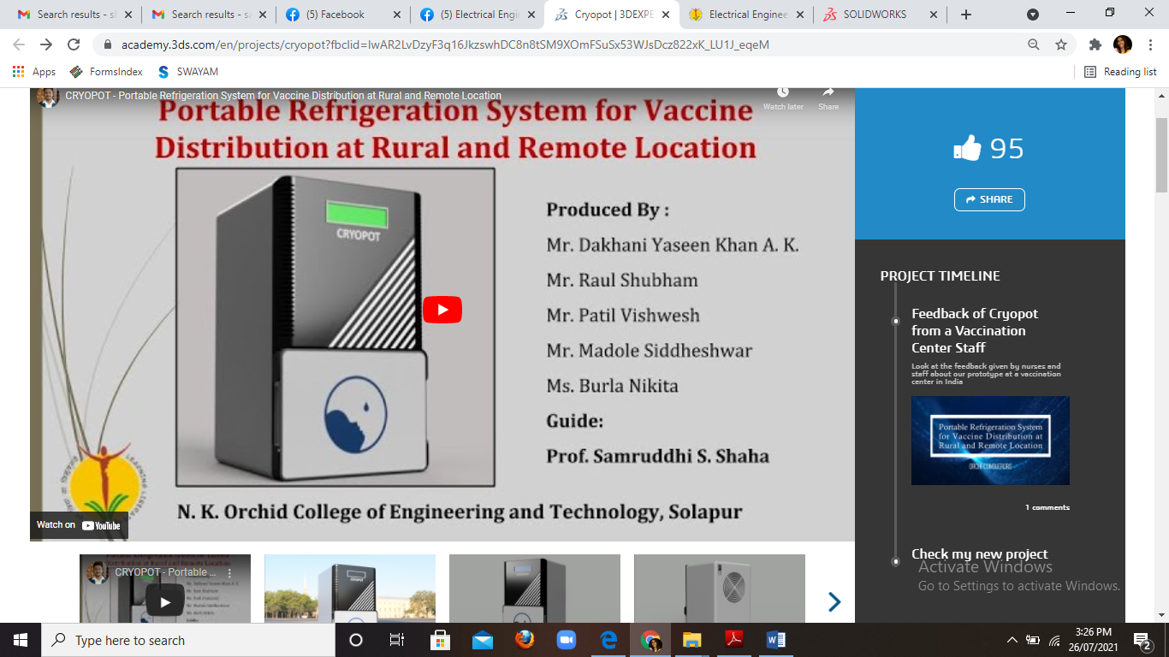
- "Portable Refrigerator System for Vaccines Distribution for Remote and Rural Area" is selected for showcase in Connect Next Virtual Conference by La Fondation Dassault Systemes on *17-18 September 2020.
